The Rosetta Initiative: Translating Between 3D's Tower of Babel
Mark Flanagan has been an architect, visual effects artist, animator, game developer, and an educator. However, these days he’s primarily focused on solving one of the most annoying problems in 3D animation.
In Flanagan’s words, “Every 3D platform has its own logic, vocabulary, way of handling materials, lighting, and simulations. If you understand one application, you should be able to transfer that knowledge to another. But currently, an artist who is fluent in Maya must start from zero if they want to move to Houdini, Blender, or 3ds Max.”
His project to unify workflows across multiple 3D applications is known as the Rosetta Initiative. Named after the ancient stone that gave scholars the ability to decode Egyptian hieroglyphs by comparing three versions of the same text. The Rosetta Initiative intends to map equivalent concepts across multiple 3D applications.
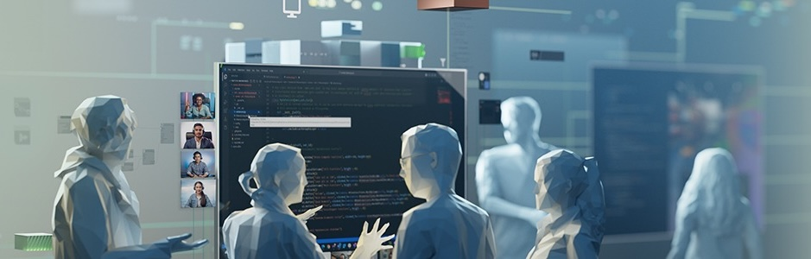Source: NVIDIA Omniverse
Flanagan is building cross-platform primers like “Maya for Blender users” and “Houdini for 3ds Max users.” The technical foundation relies on Universal Scene Description (USD) and NVIDIA Omniverse. USD is a format that multiple applications can read and write while maintaining scene hierarchies, materials, and animations across software boundaries. Omniverse extends USD’s capabilities by creating a collaborative space where different applications can work on the same scene simultaneously.
The challenge with the Rosetta Initiative is testing cross-platform workflows during continuous iteration cycles. This work requires opening massive USD scenes and running multiple applications simultaneously to verify that everything translates correctly. On traditional studio infrastructure, this kind of work would result in lengthy queue times.

Traditional Workflows are Obsolete
For years, Flanagan worked as a trainer at major studios. There was a hierarchy for who had access to the render farm, and trainers sat at the bottom.
"I'd never have priority on the render farm," Flanagan says. When he needed to run simulations in Houdini, it could take days just to get processing time. He'd send off the work and wait. The delays killed any sense of creative momentum. Hours-long gaps between iterations depleted Flanagan’s focus. He’d often find himself scoping down risky ideas because multiple renders were impractical.
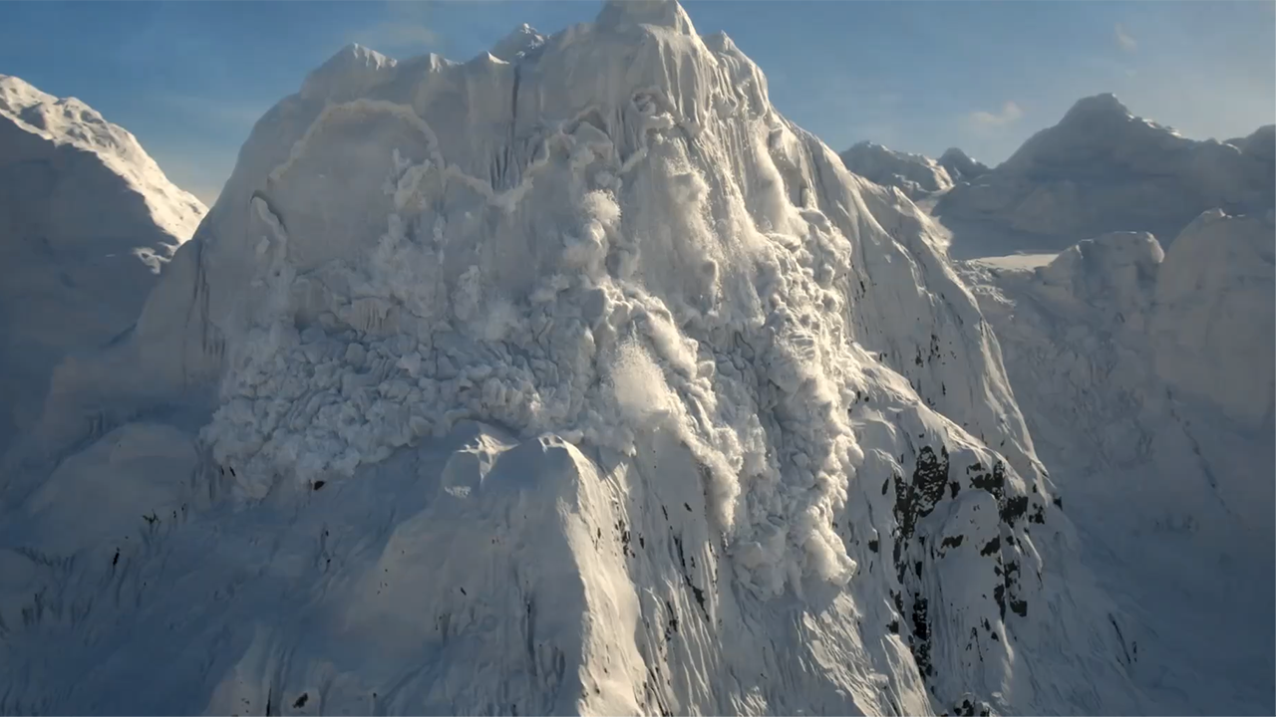Source: SideFX, Houdini VFX
Most VFX production follows a similar pattern. Artists work on thin clients connected to render farms. Assets move through multiple departments in sequence. From modeling to texturing, next to lighting, then rigging, and finally to animation. Each transition involves file format conversions, server transfers, and significant queue times.
Studios aim for what they call a ten-minute pipeline. That's the goal for moving an asset through the entire process. "I've never actually worked for a company that's hit the ten-minute pipeline," Flanagan notes, "They're usually significantly longer than that."
The Rosetta Initiative wouldn't survive on traditional infrastructure. Continuous testing requires constant iteration across multiple applications, so render queues would make the work impractical.

From Farm to Desktop
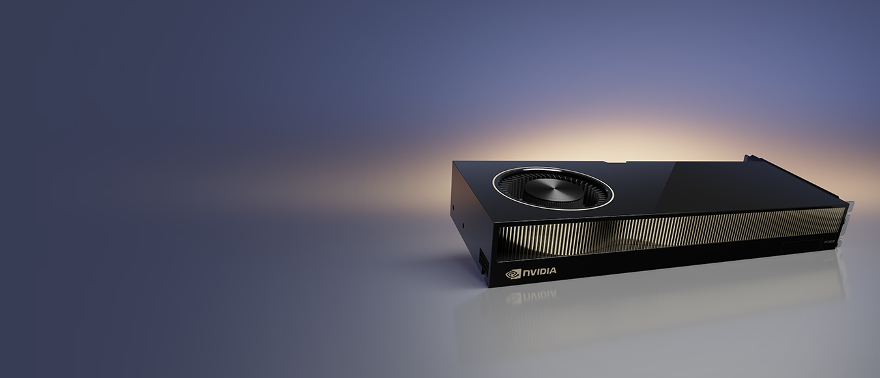Source: NVIDIA RTX PRO 6000 Ada Generation
Flanagan resumed testing his project after he gained access to a Dell workstation with an NVIDIA RTX 6000 Ada Generation GPU. The workstation unlocked new capabilities. Simulations that needed hours in render queues processed in minutes. Now, he’s able to open massive USD scenes across multiple applications simultaneously.
Early on, Flanagan realized the work that used to require a render farm now fits entirely in the graphics card on his desk.
"When I'm trying to work across different platforms and show people how they can achieve similar results, it doesn’t take hours. It only takes seconds," Flanagan says. "I don't have to go away for a day and come back and try to pick up where I was. I now have a state of flow."

The Future for Creative Technologists
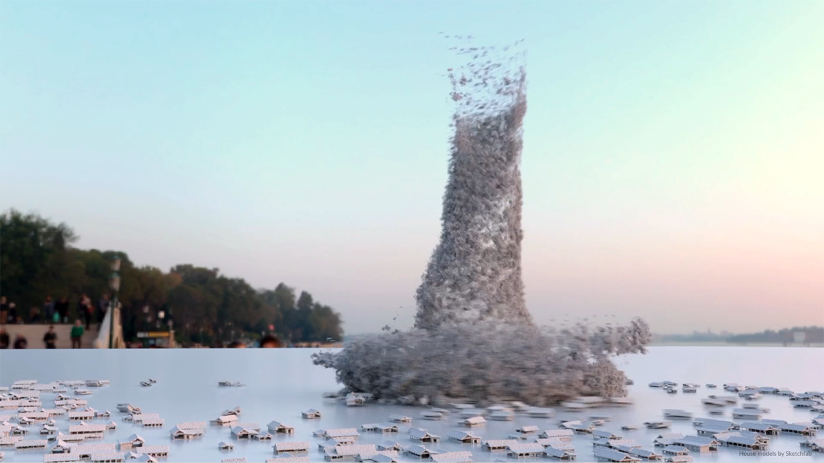Source: SideFX, Houdini MPM
The transformation Flanagan describes represents a broader shift in who can become a creative technologist.
For years, ambitious 3D projects required institutional infrastructure. Individual artists needed to be attached to studios to access the processing power their work demanded. The Dell workstation on Flanagan's desk provides those same capabilities. He can run the Rosetta Initiative from his office.
"When you can just play with applications and see your changes, things make intrinsic sense," Flanagan explains. "I understand my work at a much better level than by only understanding the mathematics or the art, because I can see changes based on both."
Immediate feedback removes the fear of experimentation. "Iteration is one of the great friends of art and innovation," Flanagan says. "If you can see the changes you make in context, you can get it right so much more quickly. You can make mistakes more quickly, but all those mistakes lead to going in the right direction."
The Rosetta Initiative aims to break down barriers between applications. The Dell and NVIDIA hardware that enables it is breaking down a different barrier, the one between institutional capabilities and individual access.

The future of creative technology isn’t locked behind studio walls anymore. With Dell Pro Max workstations and NVIDIA RTX PRO GPUs, artists can iterate faster, experiment fearlessly, and bring ambitious ideas to life—all from their own desks. Whether you’re building cross-platform workflows or pushing the limits of visual effects, this is the hardware that keeps you in the flow.
Ready to level up your creative process? To learn more about Dell Pro Max workstations accelerated by NVIDIA, click here.

